R3

REDUCE RECYCLE REUSE

**Project Team : PG8**

**Team Member’s :** Sarika Bommavaram(08)

Gouri Priya Vangavargu(50)

Sankalp Racharla(43)

Sasidhar Malladi(32)

**INTRODUCTION**

Reduce, reuse and recycle is a concept that people everywhere are starting to understand and apply to everyday life. Its principles are quite basic, but are important for maintaining a sustainable life. To remain productive, reducing one’s intake of energy and materials is vital. The toxicity of trash is at an all-time high and the only way to stop this is by preventing waste from the very beginning of its life. The concept of reuse is applied by reinventing items after their initial life and avoiding additional waste by all means necessary. Recycling is the process of turning items considered to be waste into a valuable resource. This process does include many steps, but begins with taking items such as cans, glass, newspapers or plastic to a recycle bin or collection facility. The more often individual users partake in this practice by consciously making themselves aware of an item’s recyclability, the easier the entire process will be for the rest of the world. This ease will simply create a higher demand for recycled products and will be more of an incentive for large corporations to use and buy recycled products, making the entire process more successful and stress free. These simple ideas of reduce, reuse, recycle are just the beginning of challenging ourselves in preserving our environment.

The notion of reduce, reuse and recycle was obvious when developing a concept for Resource Management. To improve efficiency of resource management by using three R’s we are proposing an application which can automate the whole process and also manages scheduling of waste collection thus no resources are wasted by anyone.

This application gives us answers all the questions about waste management in Kansas City. One has to plan time and date to get all the waste together. To schedule time we have collection calendar which helps us to get information of time and date of waste collections. We can also get reminders before the specified deadline of collection. Now after scheduling time and date one has to know about the place or collection point where we have to drop the waste. For this application provides a solution by giving information of collection points near to you and also you can get map to get to that place. The application also provides us a sorting guide through which one can sort waste in their home to different categories such as electronic appliances, glass, household waste etc. It has a local storage which will store you address automatically and reduces overhead of entering address every time. If anyone is busy at that they can also schedule time and send request to pick up the recycling waste.

If we are considering in driver perspective view also this application is useful because he can get list of places where he can collect the waste and by giving his place he can get a map through all the collection points available and also minimum distance through them.

**PROJECT GOAL AND OBJECTIVES**

**OVERALL GOAL**

* Our goal is to automate the process of recycling and waste management thus users can find ease in participating in this process and save environment.
* For this we are developing a mobile application so that it may be in reach of everyone.
* We are using mash up service involving in using several API’s such as Google maps etc.

**PROBLEM STATEMENTS**

* Main problem in our community is resource management. Day by day resources are exhausting and in order to preserve them we have to manage available resources. One of effective way is recycling process.
* Many people in the community are not aware of recycling process and also waste the recycling materials by throwing into trash.
* Many people are not aware of dividing waste according to specified category.
* General problem faced is people don't know recycling points.
* Due to these reasons we are not completely recycling waste in our community.

**SIGNIFICANCE**

* We are intend to develop a user interactive mobile application which will improve methods and efficiency of recycling waste.
* Usage of API’s such as maps and speech to voice etc. will improve its importance and also thus user can use it with ease.
* Calendar and reminder service will help in scheduling user time and knowing time and place to drop the waste.
* Ease for the pickup service men to drive through the shortest route between collection points.
* It also provide option to donate stuff.

**PROJECT BACKGROUND & RELATED WORK**

**PROJECT BACKGROUND**

We have done some research regarding project background and by guidance of Dr.Lee we found that there is a project developed in Belgium named as recycle. This application asks us to enter zip code and gives collection points near us.

We have also done research regarding implementing project in Kansas City and found collection points exit and are trying to develop mobile application to manage resources.

**SIMILARITIES**

One similarity which we can find in applications is we are working on project of same background i.e., waste management in a city and we are trying to locate recycle points and connect people to it to get all recycling stuff at one place.

**Requirement Specification:**

***Functional Requirements:***

Home Page : To differentiate the Service provider and Community people

Zip code : To locate the nearest recycling drop off places

Donation : To give away the unused and undesired products and stuff (Reuse)

Calendar : To specify the dates and times for the trash pickup or drop off

Notifications: It’s like remainder for recycling to community people

Database : To store the service provider details to authenticate

Local Storage : To store the entered Zip code for further process

***Non-functional Requirements:***

|  |  |
| --- | --- |
| **Non-Functional Requirement** | **System or Feature Level** |

Service provider has to be authenticated   
 to see the locations to pick up the trash System

Zip code must be valid Feature

**Technical/business Requirements:**

Google API,Calendar API

**Business Process/Workflow analysis (UML Activity Diagram)**



**Technological and Architectural requirements:**

* App developed id available to all android mobiles in play store
* App will develop in Android Studio
* Database used to store data is SQL server
* Google Maps API, Calendar API, TextToVoice API

***SYSTEM ARCHITECTURE:***

****3) System Specification: Identify Primary Services

• Existing Services:

Name: Recycle! App

**Description:** The app answering all of your questions on waste in Belgium: an overview of all waste collections on your street (from 01.01.2014), all collection points near you—including container parks and re-use centers—and a sorting guide that helps you sort your waste correctly

URL:  [https://play.google.com/store/apps/details?id=mobi.inthepocket.fostplus.recyclage&hl=en](%20https:/play.google.com/store/apps/details?id=mobi.inthepocket.fostplus.recyclage&hl=en)

**New Services to be built:**

We are going to add Pick up service additionally for the previous app with much interested UI. And In this App User can post about donating his unused and undesired stuff. Feedback service will also increment.

**Class diagram**



• Sequence diagram



**• Service Specification**

o Operational description: This service introduced for service provider to log in and collect the recycle trash by reaching the community places. The pickup locations are given by community people sometimes when they are not able to drop off.

o Input/output for services: Input will be current position such that map will be displayed nearest pick up locations of community with amount of distance.

o Service flow/alternative flow: we can select from the service

o Constraints/exceptions: Service provider has to login.

o Priorities (degree of importance, difficulty, etc.): Less distance has more importance

• Design of Mobile Client

Features: Android

Styles: CSS, HTML5

Technologies: Android Studio, SQL

**Risk Management:**

There are several Risks in developing this Project.

Sometimes there may be chances that the Reminder will not be automatically updated. In such cases the automatic reminder will fail to send remind to the service provider. To manage this Risk we will try to develop the Android application in such a way that this problem will be overcome.

There are some risks involved based on the person geographic location. If the community person is in some other place and he wish to access the app to recycle the item from his home. At that time the app will show the nearby places that are close to his location. So, In order to overcome this issue we will try to develop the app by asking his Zip code. Such that we will display the location based on the Zip code.

The Risk is with the option given to the User that he can schedule many times a week by this many of them may not be getting a chance to use this service. Here we overcome this issue by giving them chance of getting the service only weekly twice.

**Plan by Services (using ScrumDo) – include screenshots to your report**

As of now we got 12 stories to be done by us for each increment and we will update as the project work progresses further.

And we have divided the whole project into four increments and we assign certain characteristics for the App to implement each time as an increment. Each increment is counted as iteration in scrumDo and has its start dates and estimated dates to complete.

The screen shots for the stories in ScrumDo as follows

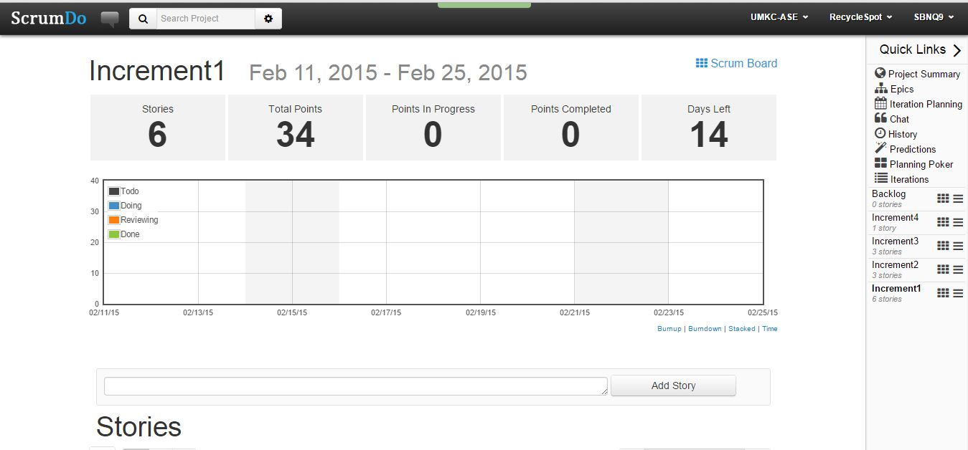

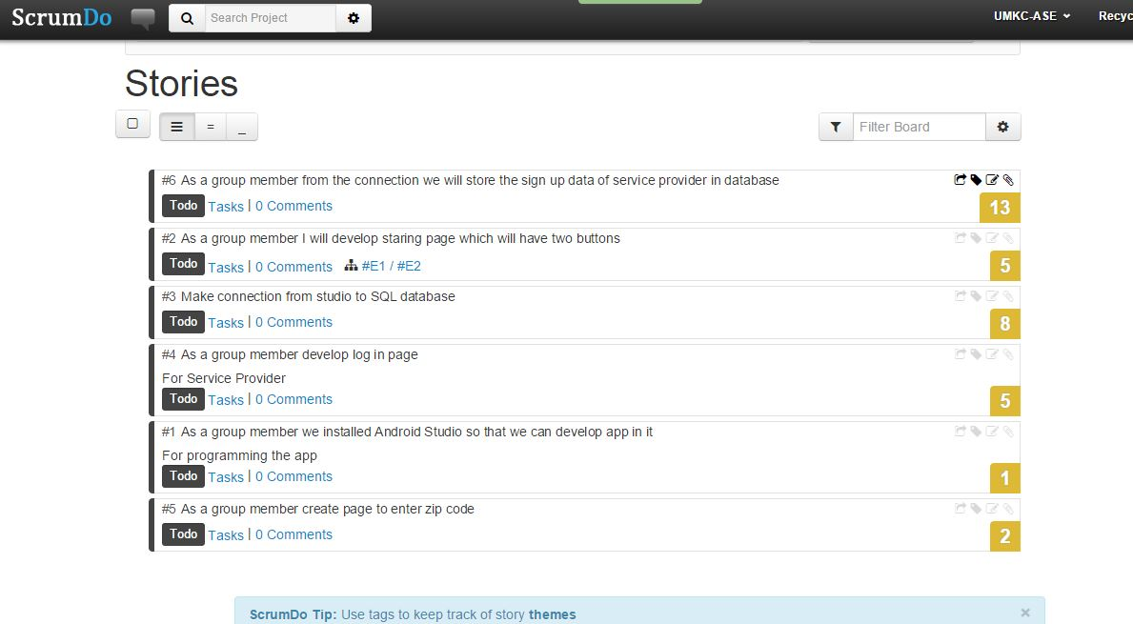

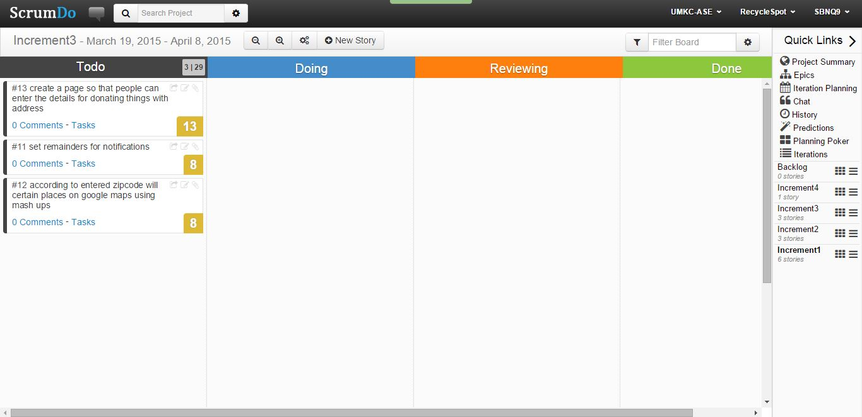

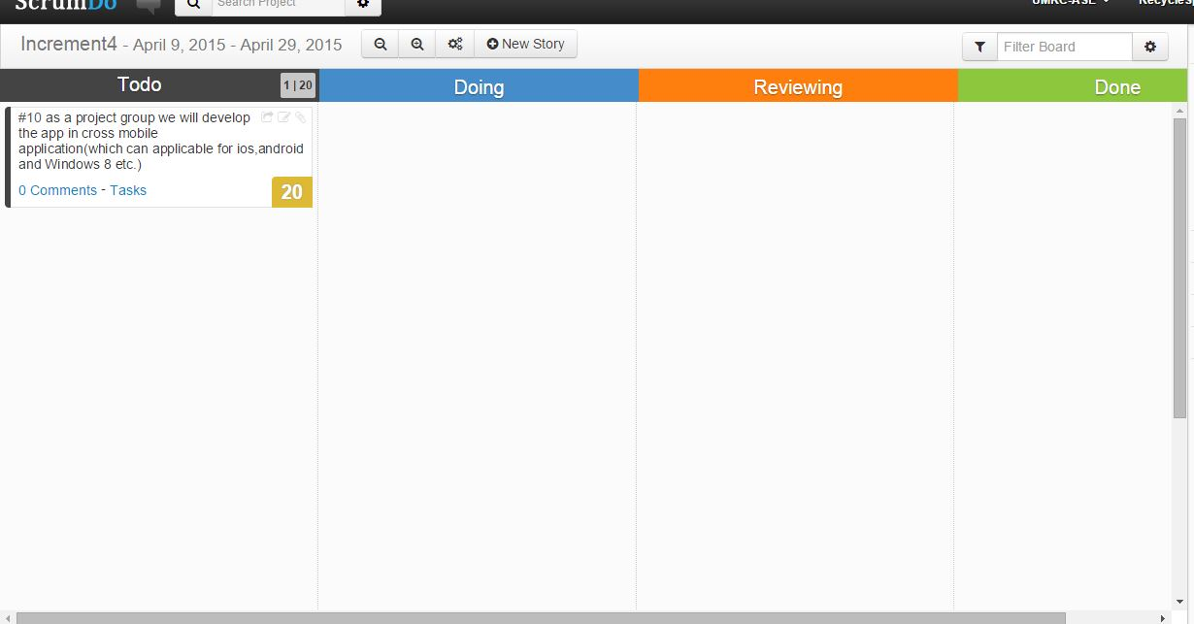

**And the overall** 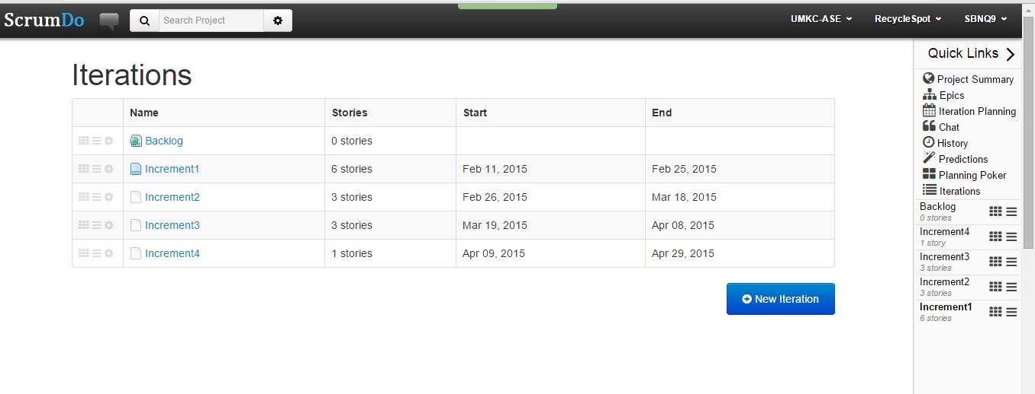

The overall Combat ability mode for our project is as shown below

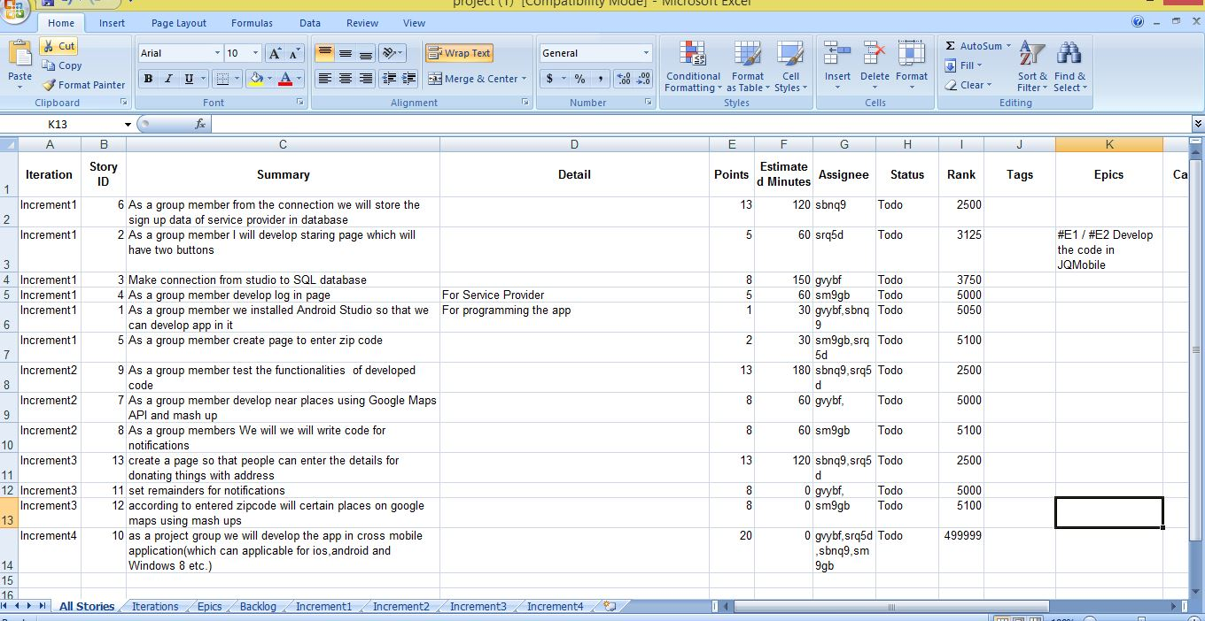

BIBLOGRAPHY:

<https://play.google.com/store/apps/details?id=mobi.inthepocket.fostplus.recyclage&hl=en>

<recyclespot.org/Take-Action/In-Your-Community.aspx>

<http://rippleglasskc.com/>

<http://www.recyclespot.org/New-Service-Providers/Kansas-City-Missouri-Solid-Waste-Services/Kansas-City-Mo-Recycling-Center-(East-Bottoms).aspx#>

<http://agilemodeling.com/artifacts/technicalRequirement.htm>

<http://www.recyclespot.org/pdf/HHWFacilitiesFlyer.aspx>

<http://www.recyclespot.org/HHW/Mobile-Events.aspx>

<http://kcmo.gov/publicworks/recycling-drop-off-centers/>